User Manual Ver.1.1





This user manual and all about copyright of Autobase ATP series panel computer

© 2012 Autobase, Inc. All rights reserved.

Second edition, April, 2013

< Notice >

Information in this document is subject to change without prior notice.

**Contents**

1. ATP2B15 Configuration 5

1.1 ATP2B15 Hardware Specifications 5

1.2 Part Names and Description 6

1.3 ATP2B15 Dimensions and Panel Cut-out 7

2. Serial Communication port 8

2.1 Serial communication port 8

2.1.1 RS-232C Port 8

3. Automated System Recovery 9

3.1 System recovery 9

3.1.1 Initial state recovery 9

3.1.2 Restore point update 10

4. Manual System Recovery 12

4.1 Device driver setup 12

4.1.1 The mainboard chipset driver setup 12

4.1.2 Audio driver setup 16

4.1.3 Graphic driver setup 19

4.1.4 Touch screen driver setup 21

4.1.5 Ethernet driver setup 24

4.3 Programs for Autobase Touch Pro Pack 26

4.2.1 Autobase SCADA Program installation 26

Customer service 27

1. ATP2B15 Configuration

## 1.1 ATP2B15 Hardware Specifications

|  |  |
| --- | --- |
| Items | Model |
| ATP2B15 |
| Display | 15.0 inch LED Panel  XGA (1024 \* 768) |
| CPU | Intel ATOM D525 Dual Core 1.8GHz (FSB 800MHz) |
| Touch Controller | Pen Mount 5-wire USB controller |
| Mainboard Chipset | ICH8M |
| Main Memory | DDR3 2GB (1066MHz/PC8500) |
| Secondary Storage | SSD 60GB(Max Read:500MB/s Write:400MB/s)  or HDD 500GB(SATA2 7200RPM) |
| VGA | Intel GMA 3150 |
| Serial/Printer Port | RS-232C 3 Ports |
| USB | USB 4 Ports |
| Ethernet Port | Dual Gigabit Ethernet (10/100/1000Mbits/s) LAN Ports |
| Keyboard/ Mouse | USB Type |
| CD-ROM | - |
| OS | Windows Embedded POSReady 2009 |
| Utility | Rescue (Recovery Tools Included) |
| Voltage | DC 12V(50~60Hz) |
| Power | 38W(Max 60W) |
| Weight | 5.22 kg |
| Service life of LCD Backlight | 40,000h or more |

<Table 1-1> AUTOBASE Touch hardware specifications

## 

## 1.2 Part Names and Description

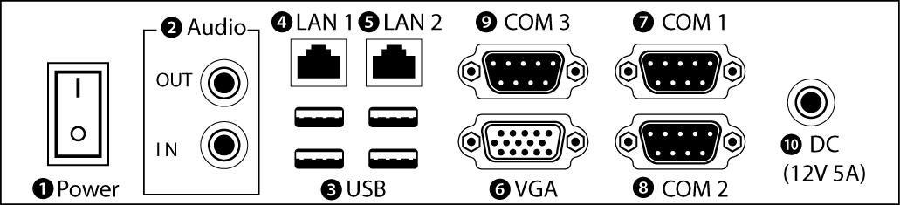

<Figure 1-1> Input/output ports of ATP series

❶ Power ON/OFF : Power On/OFF switch

❷ Audio IN/OUT : Microphone input/output ports

❸ USB : USB 4 ports

❹ LAN 1 : 10/100/1000 Base-T Ethernet port

❺ LAN 2 : 10/100/1000 Base-T Ethernet port

❻ VGA : External D-SUB VGA monitor output port

❼ COM 1 : RS-232C input/output ports

❽ COM 2 : RS-232C input/output ports

❾ COM 3 : RS-232C input/output ports

❿ COM 3 : RS-232C input/output ports

⓫ DC IN : DC-12V Power input connector

## 1.3 ATP2B15 Dimensions and Panel Cut-out

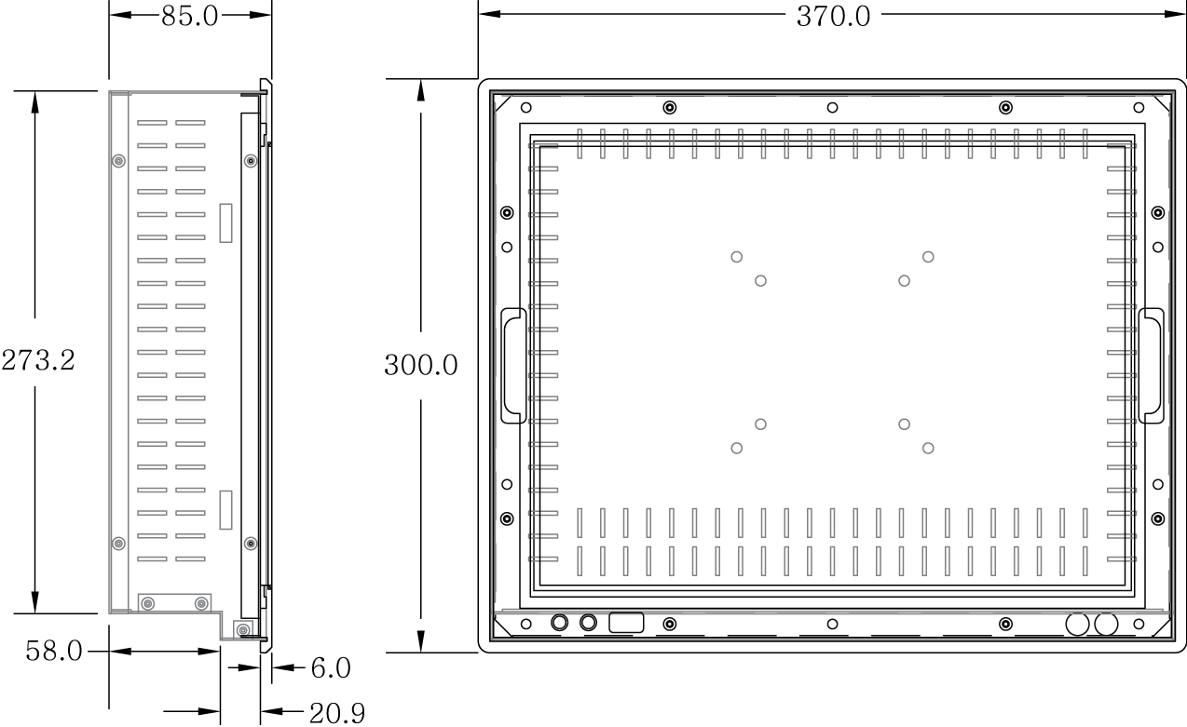

<Figure 1-2> ATP2B15 dimensions(unit : mm)  
  
  
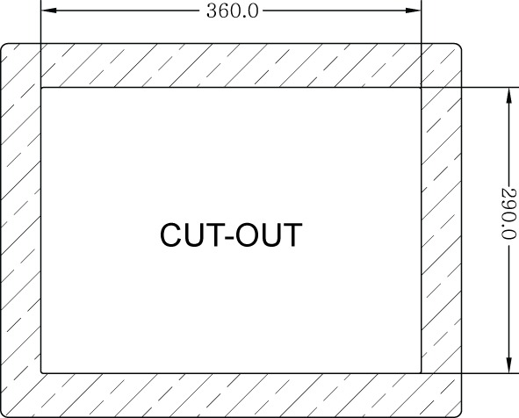

<Figure 1-3> ATP2B15 Panel cut-out dimensions(unit : mm)

2. Serial Communication port

|  |  |
| --- | --- |
| 2.1 Serial communication port ATP2B15 has 3 serial ports for communication.  Serial ports COM1/COM2/COM3 are RS-232C dedicated port so they can be used as RS-232C only. | |
| 2.1.1 RS-232C Port  COM1/COM2/COM3 serial ports support the RS-232C only.  <Table 2-1> shows pin functions for RS-232C. Before you connect device with serial port, verify the pin functions. | |  |  | | --- | --- | | Connector Type핀 Female) | | | 02-00_9핀.jpg | | | Pin Number | Function | | 1 | DCD (Data Carrier Detect) | | 2 | RXD (Receive Data) | | 3 | TXD (Transmit Data) | | 4 | DTR (Data Terminal Ready) | | 5 | GND (Ground) | | 6 | DSR (Data Set Ready) | | 7 | RTS (Request to Send) | | 8 | CTS (Clear to Send) | | 9 | RI (Ring Indicator) |   <Table 2-1> RS-232C Pin Functions |

3. Automated System Recovery

You can recover the system simply with the previous recovery point, using the recovery program, installed on Autobase Touch Panel.

## 3.1 System recovery

External keyboard is required when you have to reset Autobase Touch Panel as factory state or repair to the recent recovery point, for reasons such as the damage of operating system or loss of important data.

3.1.1 Initial state recovery

During system boot, press the ' Home ' of the keyboard, the login dialog box will be appeared, as shown in <Figure 3-1>.

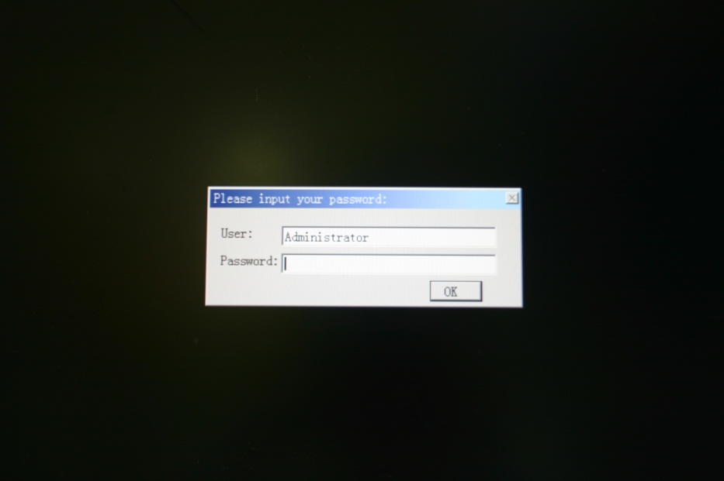

<Figure 3-1> Login dialog box

When <Figure 3-1> login dialog box is appeared, input user(as Administrator) and password(default password :admin) that you has set in the recovery program and then the recovery selection screen will be displayed as shown in <figure 3-2>.

|  |  |
| --- | --- |
| 03-02 copy3.jpg  <Figure 3-2 Recovery selection screen | When the recovery selection screen is displayed, using external keyboard, select  to recover the initial state and select  to delete the restored area. |

3.1.2 Restore point update

When you complete the commissioning and project in the field, you can update the optimal restore point for preparing of problem occurrence to the system.

After booting up Autobase Touch Panel system normally, double click the DriveX아이콘.png icon at the bottom right corner of the screen then the logon dialog box will be appeared as shown in <Figure 3-3>

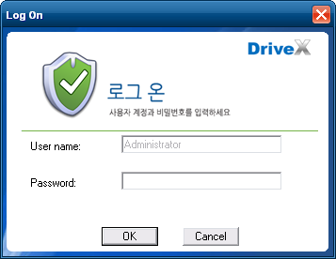

<Figure 3-3> Logon dialog box of recovery program

First of all, enter the user and password in <Figure 3-3> the logon dialog box to log on. \*Factory setting – user : Administrator, Password : admin

After log on if you select ‘Restore settings’ on the left side of dialog box, <Figure 3-4> dialog box will be appeared.

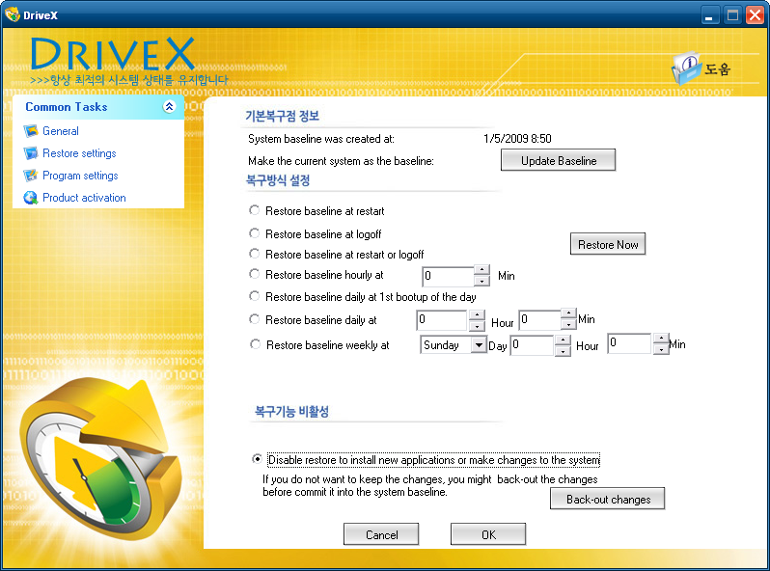

<Figure 3-4> Restore settings dialog box

And then if you select  button, the restore point will be updated.

If the restore point is updated successfully, Restore point update complete dialog box will be displayed as <Figure 3-5>.

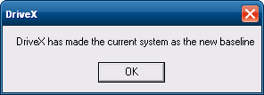

<Figure 3-5> Restore point update complete dialog box

Generally, it is recommended to choose the disable restore option in the bottom of the dialog box. And modify restore settings carefully. If you choose a restore mode, the system will be restored each time depending on how the selected restore mode. For example, if you select ‘Restore baseline at restart’, the restore point will be restored whenever the system is restarted.

4. Manual System Recovery

## 4.1 Device driver setup

Install the device driver of Autobase Touch Panel after the Windows OS setup.

You can install device drivers from Touch System Software DVD or the Internet downloading. Touch System Software DVD is included in the product package.

4.1.1 The mainboard chipset driver setup

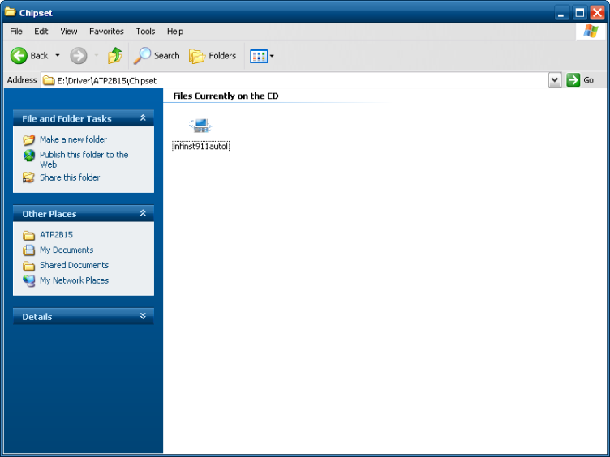

<Figure 4-1> Mainboard chipset driver folder

You can find ‘infinst911autol.exe’ file as shown in <Figure 4-1> when you select ‘Driver\ATP2B15\Chipset’ folder from Touch System Software DVD. And run ‘infinst911autol.exe’, <Figure 4-2> initial screen will be displayed. Then select  from <figure 4-2>, <Figure 4-3> license agreement dialog box will be displayed.

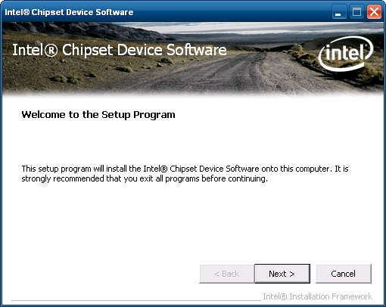

<Figure 4-2> Initial screen of the mainboard chipset driver setup

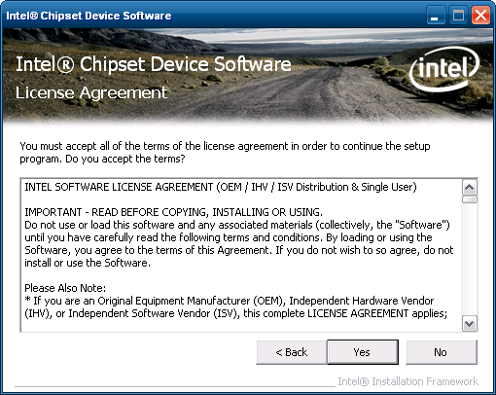

<Figure 4-3> License Agreement dialog box of mainboard chipset driver setup

If you select C:\Users\itsmejeon\Desktop\Snap5.png from <Figure 4-3>, the driver installation process will be continued. During the driver installation, if it needed an OS file, <Figure 4-4> screen will be appeared and then select the needed file in ‘\Driver\WindowsXP\_POSReady2009\_SystemFiles’ folder of Touch System Software DVD.

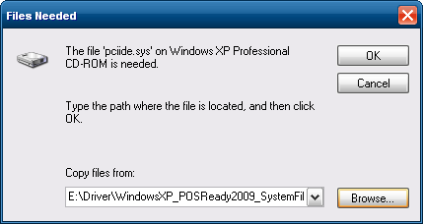

<Figure 4-4> Specify OS System Setup file

When the installation is complete, reboot system information screen will be appeared as shown in <Figure 4-5> and proceed to reboot.

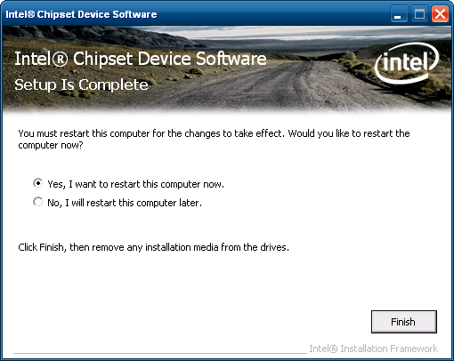

<Figure 4-5> Mainboard chipset driver installation complete screen

4.1.2 Audio driver setup

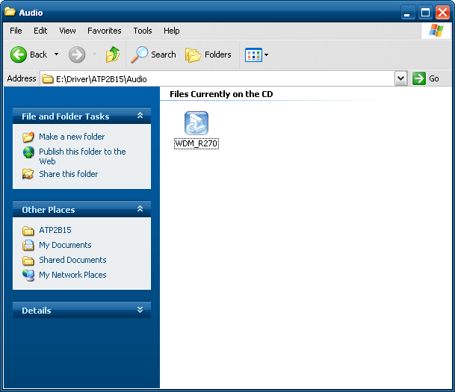

<Figure 4-6> Audio driver folder

You can find the setup file in‘Driver\ATP2B15\Audio’ folder of Touch system Software DVD. And if you run ‘WDM\_R270.exe’ from <Figure 4-6>, the initial screen will be displayed as shown in <Figure 4-7>. Then, if you select  in <Figure 4-7> it will proceed to setup. During the installation, the dialog box will be displayed to specify the related system file path as shown in <Figure 4-8>.

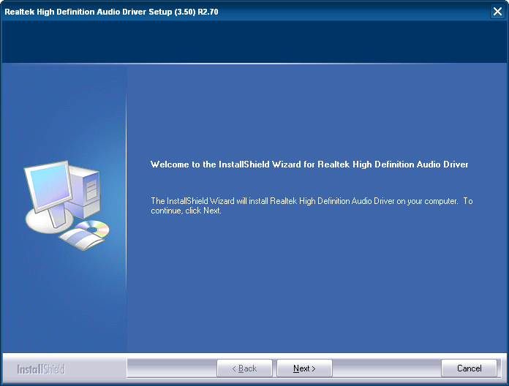

<Figure 4-7> Audio driver setup initial screen

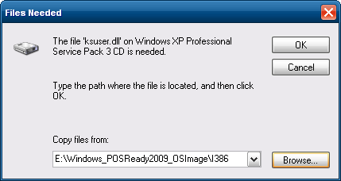

<Figure 4-8> Related system file location setting dialog box

After the related system file location setting if you select  button, the audio driver installation will be completed and Windows restart setting dialog box will be displayed as shown in <Figure 4-9>.

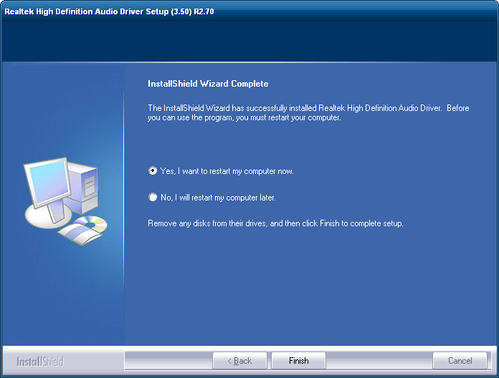

<Figure 4-9> Windows restart setting dialog box

4.1.3 Graphic driver setup

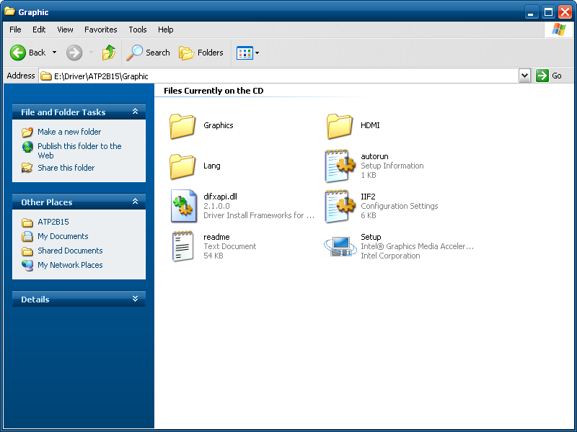

<Figure 4-10> Graphic driver folder

If you select the provided Touch System software DVD ‘Driver\ATP2B15\Graphic’ folder, the files will be displayed as <Figure 4-10>. And run ‘Setup.exe’ in <Figure 4-10>, the graphic driver setup initial screen will be appeared as <Figure 4-11>.

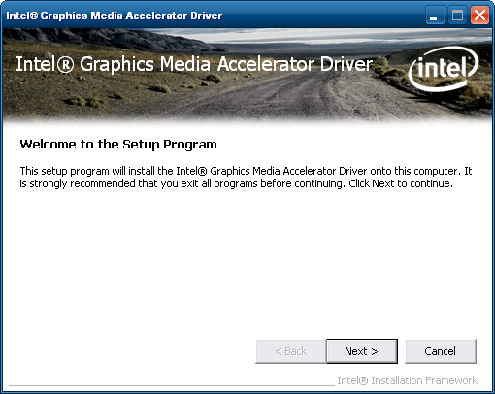

<Figure 4-11> Graphic driver setup initial screen

Then, select  button in <Figure 4-11>, the graphic driver setup will be started.

When the graphic driver setup completed <Figure 4-12> dialog box will be displayed and you can set whether to restart the computer or not. After installing the graphic driver, adjust the proper screen resolution (ATP2B15 : 1024 \* 768).

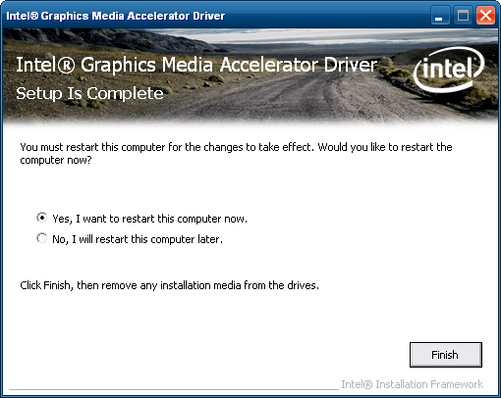

<Figure 4-12> Graphic driver setup complete dialog box

4.1.4 Touch screen driver setup

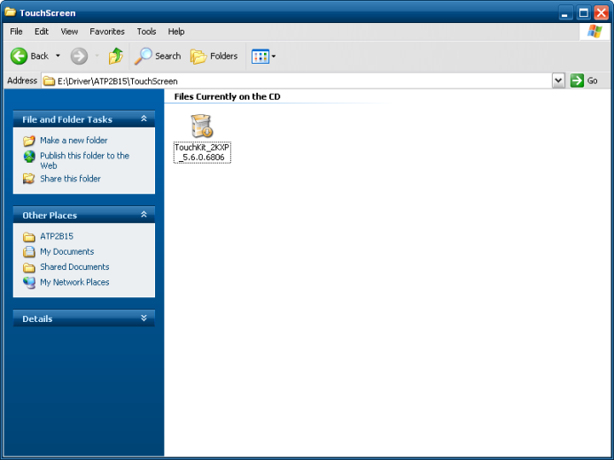

<Figure 4-13> Touch screen driver folder

If you select ‘Driver\ATP2B15\TouchScreen’ folder from Touch System Software DVD, you can find ‘TouchKit\_2KXP\_5.6.0.6806.exe’ as shown in <Figure 4-13>. And if you run ‘TouchKit\_2KXP\_5.6.0.6806.exe’, you can see the initial screen for setting as shown in <Figure 4-14>. Then, select  button, the setup program will be run and start to install the touch screen driver. After you have completed the touch screen driver installation, <Figure 4-15> dialog box will be displayed. And select  button in <Figure 4-15> dialog box, the screen calibration program will be executed as shown in <Figure 4-16>. After then, set the screen position of the touch screen with the calibration program of <Figure 4-16>. And if you need the detailed screen calibration, run ‘Configure Utility’ and select ‘Tools’ tab. Then click  button to do a finer screen calibration.

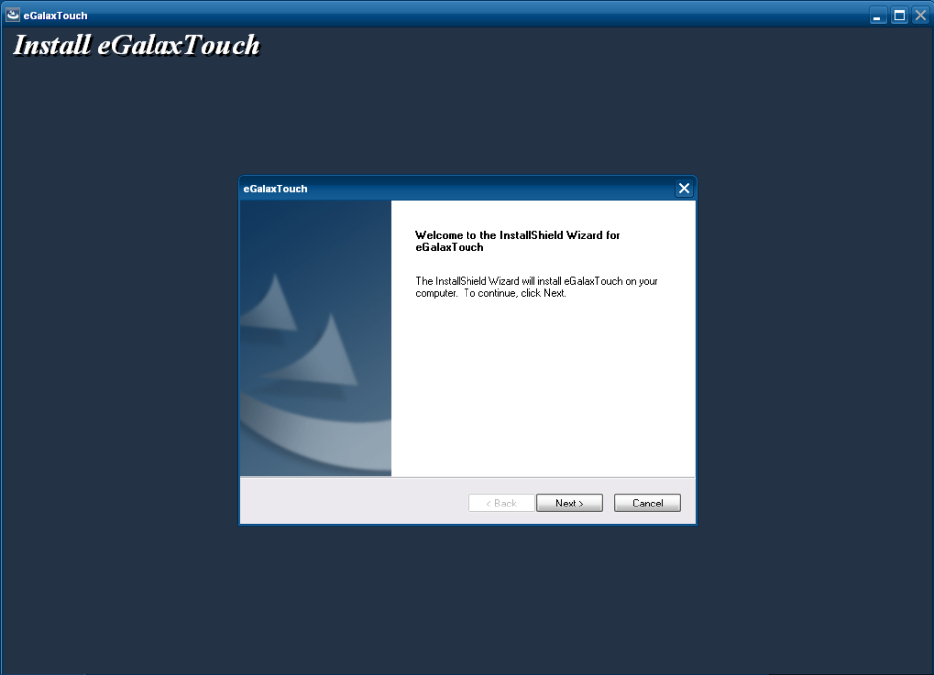

<Figure 4-14> Touch screen driver setup initial screen

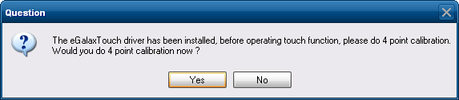

<Figure 4-15> Touch screen driver setup complete dialog box



<Figure 4-16> Touch screen calibration

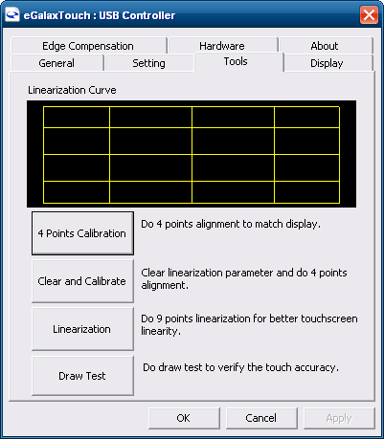

<Figure 4-17> Tools tab of Configure utility

4.1.5 Ethernet driver setup

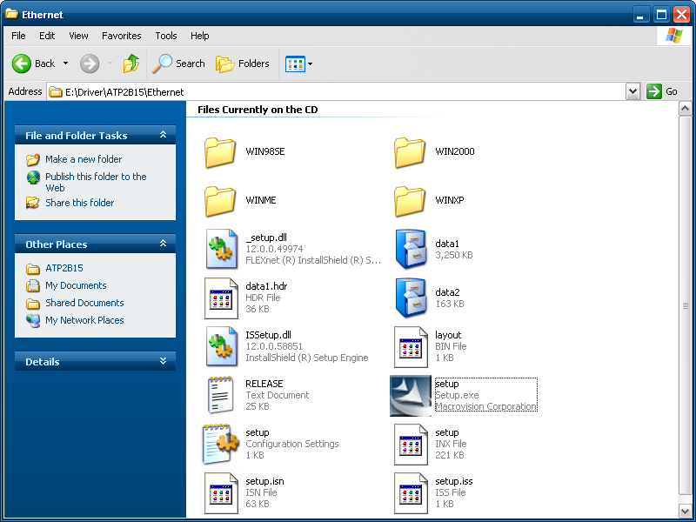

<Figure 4-18> Ethernet driver folder

When you open ‘Driver\ATP2B15\Ethernet’ folder of ‘Touch System Software DVD’, you can find files as shown in <Figure 4-18>. And if you run ‘Setup.exe’ file from ‘Driver\ATP2B15\Ethernet’ folder, installShield wizard will be started as shown in <Figure 4-19>.

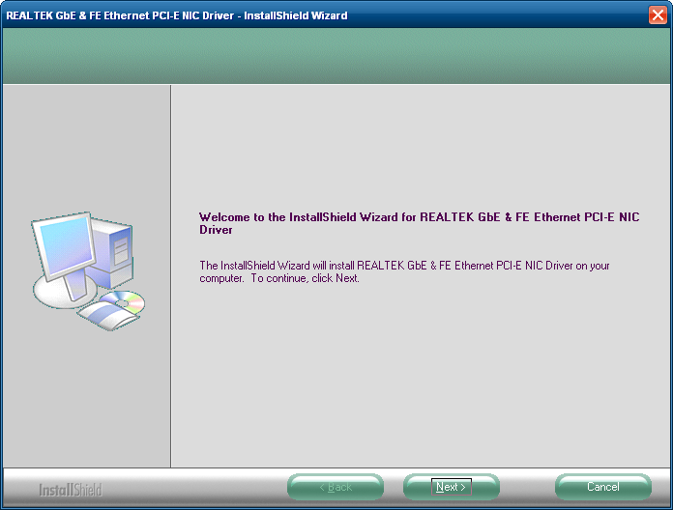

<Figure 4-19> InstallShield Wizard for graphic driver setup

Then select , installShield Wizard will start graphic driver setup. After the graphic driver installation is completed, <Figure 4-20> will be appeared.

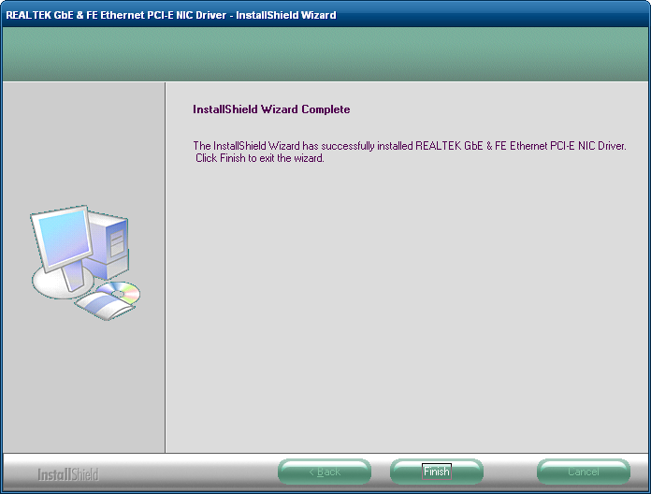

<Figure 4-20> InstallShield Wizard Complete dialog box

## 4.2 Programs for Autobase Touch Pro Pack

4.2.1 Autobase SCADA Program installation

Autobase Touch Pro Pack required Microsoft DotNet Framework, Autobase SCADA Program and Autobase SCADA license by default.

For more details about the installable Autobase SCADA version and how to install the license, contact Autobase technical support team.

|  |  |  |
| --- | --- | --- |
| Customer service | | |
| Limited Warranty |

When this product goes out of order under the normal use of customer, we will repair it free of charge for one year from the date of your purchase. Even during the warranty period, we will provide repair services with reasonable charges for problems due to customer’s negligence and natural disasters.

|  |
| --- |
| Paid service |

Autobase, Inc. does not warrant in the following cases.

❶ Malfunction by foreign substances(water, soda, coffee, toys, etc.) spills into the product.

❷ Damage and malfunction of a product due to be dropped or shocked

❸ Exterior damage and deformation in organic solvents such as thinner, benzene,

❹ Malfunction by using non-genuine parts or supplies.(ex: adapter, cooling fan, LCD, etc.)

❺ Repair and replacement of parts due to normal wear and tear.

❻ Failure due to wrong voltage.

❼ Malfunction due to the failure of connected device.

❽ Damage or loss of product parts due to disassemble by consumer

❾ Defects or damages result from repairs or modifications by someone other than customer service representative of Autobase, Inc. Technical Support Center.

❿ Failure by natural disasters(fire, flood, lightning, gas, salt, earthquake, etc.)

⓫ Reinstallation due to the improper installation of consumers

⓬ Service request, but the product has no defective parts, will be charged service fee.(Please read the user manual)

⓭ Defects or damage that result from improper operation of user.

|  |  |
| --- | --- |
| caution_Green.emf | Safety Information |
|  |  |

❶ For any reason, damage caused by disassembling the equipment will not be covered under the warranty.

❷ Do not open the cabinet to avoid electric shock. Please request service to qualified technicians.

❸ Sound or images might be distorted because to place this product near devices, emit electromagnetic waves.

❹ Protect touch panel from rain or moisture to avoid fire or electric shock.

❺ Unplug the power cord and all connected cables during thunderstorms.

❻ Connection of Network port on the touch panel is allowed 10BASE-T, 100BASE-T and 10000BASE-T. Don’t connect other kinds of network cables or telephone lines.  
Improper connection can result in the current load on the connector can cause a fire, overheating or malfunctioning.

❼ Don’t block the air-intake and exhaust vents.

❽ This touch panel surface is made of metal so if you do not use in the ground environment you can feel the subtle flow of currents.

