User Manual Ver.1.0





This user manual and all about copyright of Autobase Touch panel computers

© Autobase, Inc. All rights reserved

< Notice >

Information in this document is subject to change without prior notice.

Printed, December 20, 2012

Contents

1. ATH15 Configuration 5

1.1 ATH15 Hardware Specifications 5

1.2 Part Names and Description 6

1.3 ATH15 Dimensions and Panel Cut-out 7

2. Serial Communication port 8

2.1 Serial communication port 8

2.1.1 RS-232C Port 8

3. Automated System Recovery 9

3.1 System recovery 9

3.1.1 Initial state recovery 9

3.1.2 Restore point update 10

4. Manual System Recovery 12

4.1 Device driver setup 12

4.1.1 Raid controller driver setup 12

4.1.2 Serial port driver setup 15

4.1.3 Touch screen driver setup 18

4.2 Programs for Autobase Touch Pro Pack 21

4.2.1 Autobase SCADA program installation 21

Customer service 23

1. ATH15 Configuration

## 1.1 ATH15 Hardware Specifications

|  |  |
| --- | --- |
| Items | Model |
| ATP15 |
| Display | 15inch, XGA, (1024 \* 768) |
| CPU | Intel i5 CPU M560 2.6GHz (FSB 1066MHz) |
| Touch Controller | Pen Mount 5-wire USB controller |
| Mainboard Chipset | Intel QM57 |
| Main Memory | DDR3 2GB (1066MHz/PC8500) |
| Storage | SSD 60GB(Max Read:500MB/s Write:400MB/s) |
| VGA | Intel 945GSE integrated GMA950 |
| Serial/Printer Port | 2 RS-232C Port |
| USB | 4 USB Ports |
| Ethernet Port | Dual Gigabit Ethernet (10/100/1000M BaseT) LAN Ports |
| Keyboard/Mouse | USB Type |
| CD-ROM | - |
| OS | Windows Embedded Standard 7 |
| Utility | Rescue (Recovery Tools Included) |
| Voltage | AC 115 ~230V |
| Power | 113W |
| Weight | 6.25 kg |
| Service Life of LCD Backlight | 40,000h or more |

<Table 1-1> AUTOBASE ATH15 hardware specifications

## 

## 1.2 Part Names and Description

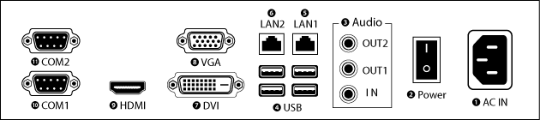

<Figure 1-1> ATH15 Input/Output ports

❶ AC IN : Power input connector

❷ Power ON/OFF : Power ON/OFF switch

❸ Audio OUT : Stereo speaker output ports

❹ USB : USB 4 ports

❺ LAN 1 : 10/100/1000 Base-T Ethernet port

❻ LAN 2 : 10/100/1000 Base-T Ethernet port

❼ DVI : External DVI monitor output port

❽ VGA : External D-SUB VGA monitor output port

❾ HDMI : External HDMI monitor output port

❿ COM 1 : RS-232C input/output ports

⓫ COM 2 : RS-232C input/output ports

## 1.3 ATH15 Dimensions and Panel Cut-out

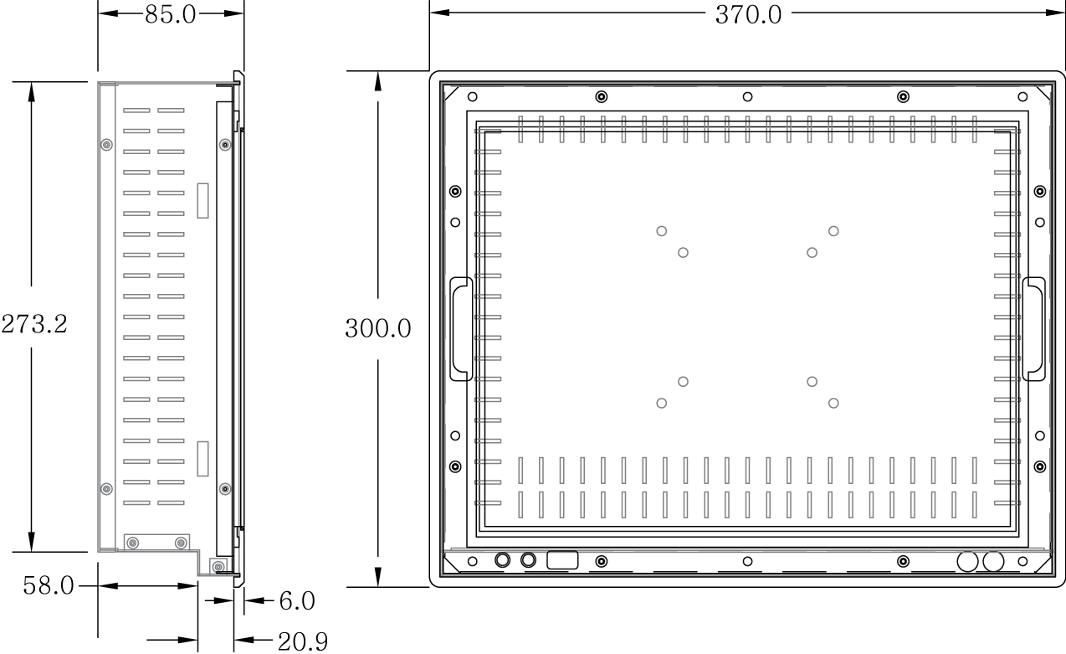

<Figure 1-2> ATH15 dimensions(Unit : mm)  
  
  
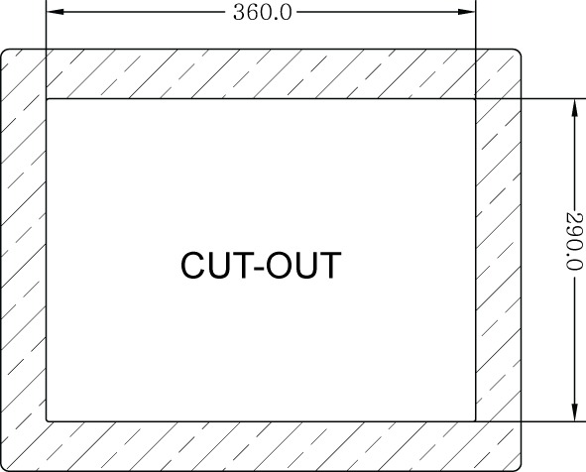

<Figure 1-3> ATH15 Panel Cut-out dimensions(Unit : mm)

2. Serial Communication port

|  |  |
| --- | --- |
| 2.1 Serial communication port ATH15 has two COM ports for serial communications. | |
| 2.1.1 RS-232C Port  COM1/COM2 serial ports support the RS-232C only. <Table 2-1> shows pin functions for RS-232C. Before you connect device with serial port, verify the pin functions. | |  |  | | --- | --- | | Connector Type | | | 02-00_9핀.jpg | | | Pin Number | Function | | 1 | DCD (Data Carrier Detect) | | 2 | RXD (Receive Data) | | 3 | TXD (Transmit Data) | | 4 | DTR (Data Terminal Ready) | | 5 | GND (Ground) | | 6 | DSR (Data Set Ready) | | 7 | RTS (Request to Send) | | 8 | CTS (Clear to Send) | | 9 | RI (Ring Indicator) |   <Table 2-1> RS-232C Pin Functions |

3. Automated System Recovery

You can recover the system simply with the previous recovery point, using the recovery program, installed on Autobase Touch Panel.

## 3.1 System recovery

External keyboard is required when you have to reset Autobase Touch Panel as factory state or repair to the recent recovery point, for reasons such as the damage of operating system or loss of important data.

3.1.1 Initial state recovery

While the system is booting up, press ‘Home’ on your keyboard then the login dialog box will be appeared as shown in <Figure 3-1>

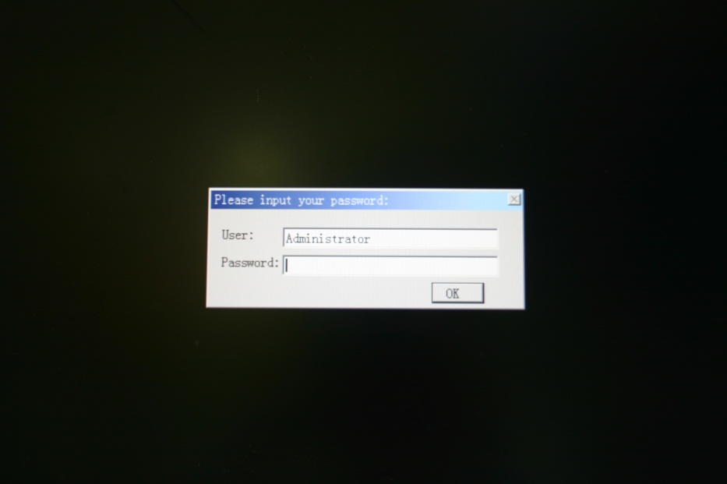

<Figure 3-1> Login dialog box

When <Figure 3-1> login dialog box is appeared, input user(as Administrator) and password(default password :admin) that you has set in the recovery program and then the recovery selection screen will be displayed as shown in <figure 3-2>.

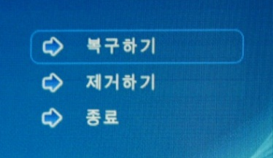

<Figure 3-2> Recovery selection screen

When the recovery selection screen is displayed, using external keyboard, select  to recover the initial state and select  to delete the restored area.

3.1.2 Restore point update

When you complete the commissioning and project in the field, you can update the optimal restore point for preparing of problem occurrence to the system.

After booting up Autobase Touch Panel system normally, double click the DriveX아이콘.png icon at the bottom right corner of the screen then the logon dialog box will be appeared as shown in <Figure 3-3>. Then enter the user and password in <Figure 3-3> the logon dialog box to log on. (\*Factory setting – user : Administrator, Password : admin)

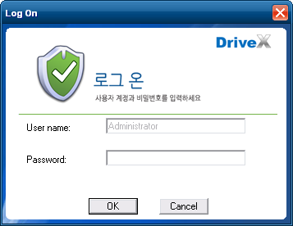

<Figure 3-3> Logon dialog box of recovery program

After log on if you select ‘Restore settings’ on the left side of dialog box, <Figure 3-4> dialog box will be appeared.

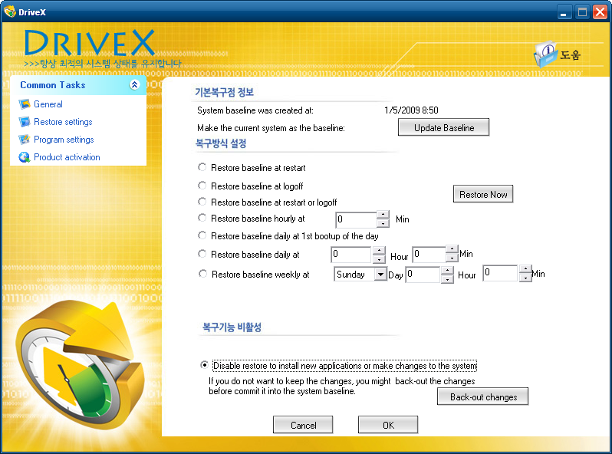

<Figure 3-4> Restore settings dialog box

And then if you select  button, the restore point will be updated.

If the restore point is updated successfully, Restore point update complete dialog box will be displayed as <Figure 3-5>.

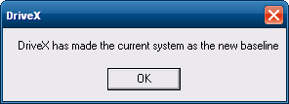

<Figure 3-5> Restore point update complete dialog box

Generally, it is recommended to choose the disable restore option in the bottom of the dialog box. And modify restore settings carefully. If you choose a restore mode, the system will be restored each time depending on how the selected restore mode. For example, if you select ‘Restore baseline at restart’, the restore point will be restored whenever the system is restarted.

4. Manual System Recovery

## 4.1 Device driver setup

Install the device driver of Autobase Touch Panel after the Windows Embedded Standard 7 OS setup.

You can install device drivers from Touch System Software DVD or the Internet downloading. Touch System Software DVD is included in the product package.

4.1.1 Raid controller driver setup

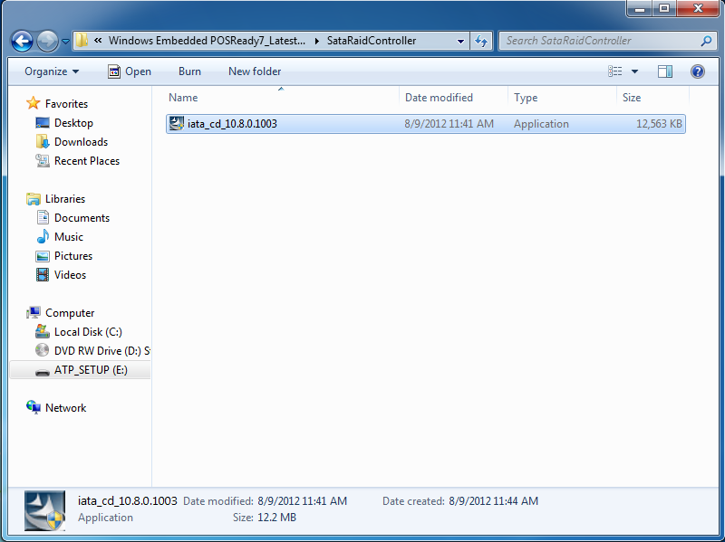

<Figure 4-1> Raid controller driver folder

Select ‘Driver\ATH15\SataRaidController’folder from Touch System Software DVD, you can find files as shown <Figure 4-1>. And execute ‘iata\_cd\_10.8.0.1003.exe’ then raid driver setup initial screen will be displayed as <Figure 4-2>

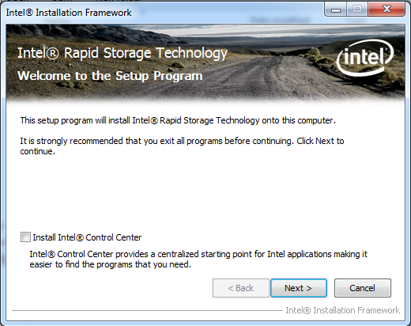

<Figure 4-2> Raid Controller driver setup initial screen

Select  button on <Figure 4-2>, Setup Program start to install the Raid controller driver.

Raid controller driver setup complete dialog box will be displayed when the Raid Controller driver setup is complete as shown in <Figure 4-3> and you can choose whether to restart the computer.

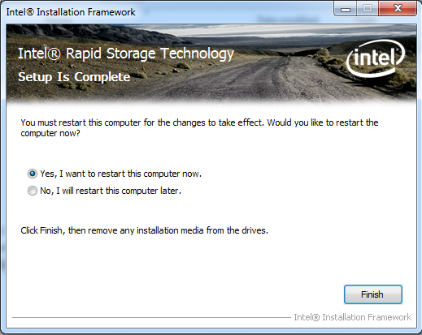

<Figure 4-3> Raid controller driver setup complete dialog box

4.1.2 Serial port driver setup

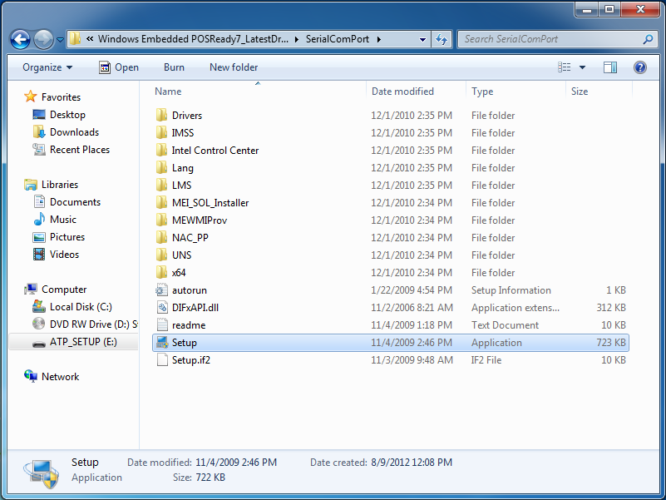

<Figure 4-4> Serial port driver folder

Open ‘Driver\ATH15\SerialComPort’folder from Touch System Software DVD and execute ‘Setup.exe’. Then the serial port driver setup program initial screen will be displayed as shown in <Figure 4-5>

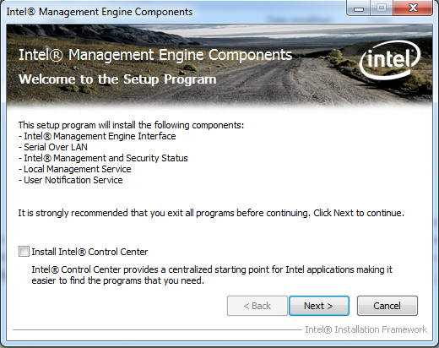

<Figure 4-5> Serial port driver setup initial screen

Select  button, the serial port driver setup will be started.

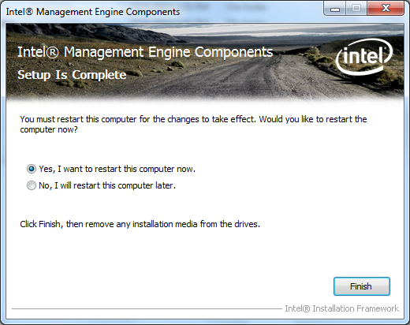

<Figure 4-6> Serial port driver setup complete dialog box

The serial port driver setup is completed, the setup complete dialog box will be displayed as shown in <Figure 4-6>

4.1.3 Touch screen driver setup

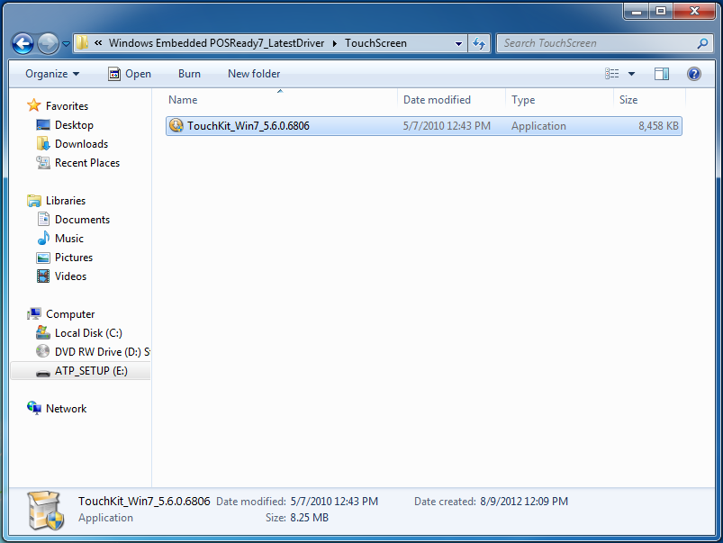

<Figure 4-7> Touch screen driver folder

If you select ‘Driver\ATH15\TouchScreen’ folder from Touch System Software DVD, you can find ‘TouchKit\_2KXP\_5.6.0.6806.exe’ as shown in <Figure 4-7>. And if you run ‘TouchKit\_2KXP\_5.6.0.6806.exe’, you can see the initial screen for setting as shown in <Figure 4-8>. Then, select  button, the setup program will be run and start to install the touch screen driver. After you have completed the touch screen driver installation, <Figure 4-9> dialog box will be displayed. And select  button in <Figure 4-9> dialog box, the screen calibration program will be executed as shown in <Figure 4-10>. After then, set the screen position of the touch screen with the calibration program of <Figure 4-10>. And if you need the detailed screen calibration, run ‘Configure Utility’ and select ‘Tools’ tab. Then click  button to do a finer screen calibration.

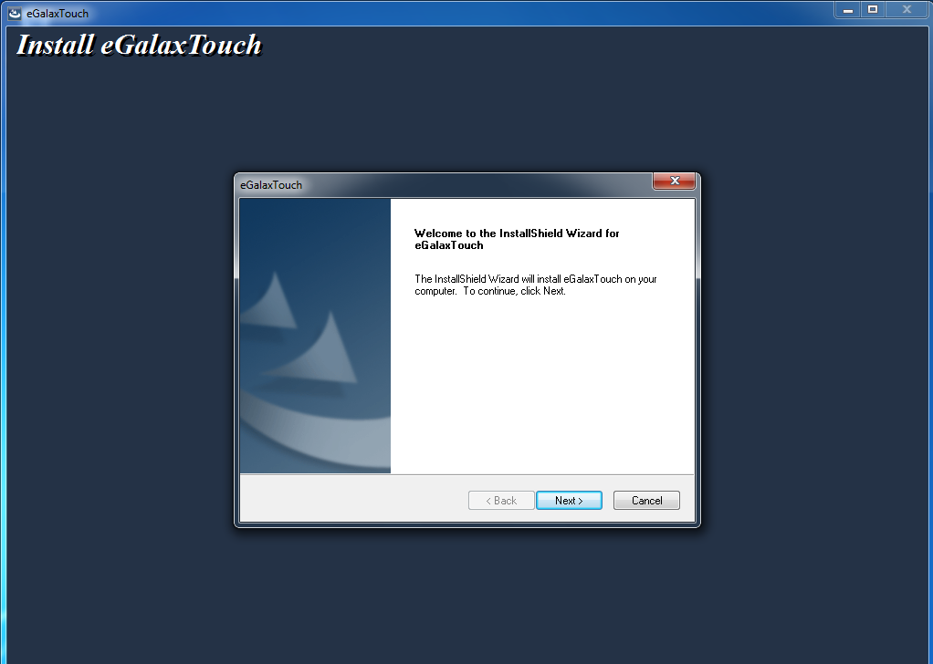

<Figure 4-8> Touch screen driver setup initial screen

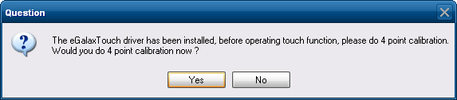

<Figure 4-9> Touch screen driver setup complete dialog box



<Figure 4-10> Touch screen calibration

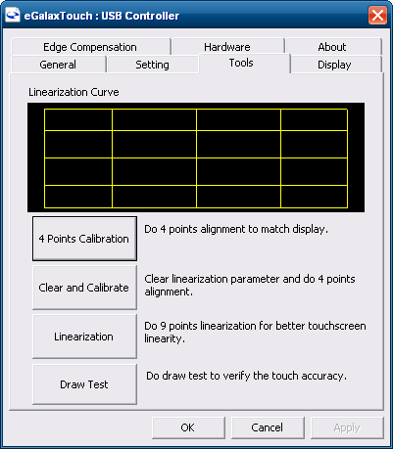

<Figure 4-11> Tools tab of Configure utility

## 4.2 Programs for Autobase Touch Pro Pack

4.2.1 Autobase SCADA program installation

Autobase Touch Pro Pack required Microsoft DotNet Framework, Autobase SCADA Program and Autobase SCADA license by default.

For more details about the installable Autobase SCADA version and how to install the license, contact Autobase technical support team.

< Empty Page >

|  |  |  |
| --- | --- | --- |
| Customer service | | |
| Limited Warranty |

When this product goes out of order under the normal use of customer, we will repair it free of charge for one year from the date of your purchase. Even during the warranty period, we will provide repair services with reasonable charges for problems due to customer’s negligence and natural disasters.

|  |
| --- |
| Paid Service |

Autobase, Inc. does not warrant in the following cases.

❶ Malfunction by foreign substances(water, soda, coffee, toys, etc.) spills into the product.

❷ Damage and malfunction of a product due to be dropped or shocked

❸ Exterior damage and deformation in organic solvents such as thinner, benzene,

❹ Malfunction by using non-genuine parts or supplies.(ex: adapter, cooling fan, LCD, etc.)

❺ Repair and replacement of parts due to normal wear and tear.

❻ Failure due to wrong voltage.

❼ Malfunction due to the failure of connected device.

❽ Damage or loss of product parts due to disassemble by consumer

❾ Defects or damages result from repairs or modifications by someone other than customer service representative of Autobase, Inc. Technical Support Center.

❿ Failure by natural disasters(fire, flood, lightning, gas, salt, earthquake, etc.)

⓫ Reinstallation due to the improper installation of consumers

⓬ Service request, but the product has no defective parts, will be charged service fee.(Please read the user manual)

⓭ Defects or damage that result from improper operation of user.

|  |  |
| --- | --- |
| caution_Green.emf | Safety Information |

❶ For any reason, damage caused by disassembling the equipment will not be covered under the warranty.

❷ Do not open the cabinet to avoid electric shock. Please request service to qualified technicians.

❸ Sound or images might be distorted because to place this product near devices, emit electromagnetic waves.

❹ Protect touch panel from rain or moisture to avoid fire or electric shock.

❺ Unplug the power cord and all connected cables during thunderstorms.

❻ Connection of Network port on the touch panel is allowed 10BASE-T, 100BASE-T and 10000BASE-T. Don’t connect other kinds of network cables or telephone lines.  
Improper connection can result in the current load on the connector can cause a fire, overheating or malfunctioning.

❼ Don’t block the air-intake and exhaust vents.

❽ This touch panel surface is made of metal so if you do not use in the ground environment you can feel the subtle flow of currents.

